**PROJECT REPORT**

**1. INTRODUCTION**

**1.1. OVERVIEW**

**The project in the zoho books for Healthhub Medical Clinic involves the creation of financial statement, which includes income statement, balance sheet and cash flow statement these statement are essential to assess the financial wealth of the company.**

**1.2 PURPOSE**

**By creating a financial statement In the zoho books we can gain deep understanding of our company’s financial standing and make strategic adjustments to improve your performance and it helps in identify the trends.**

**2. PROBLEM DEFINITION & DESIGN THINKING**

**2.1 EMPHATHY MAP**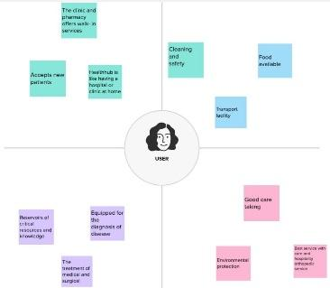

**2.2 IDEATION & BRAINSTROMING MAP**

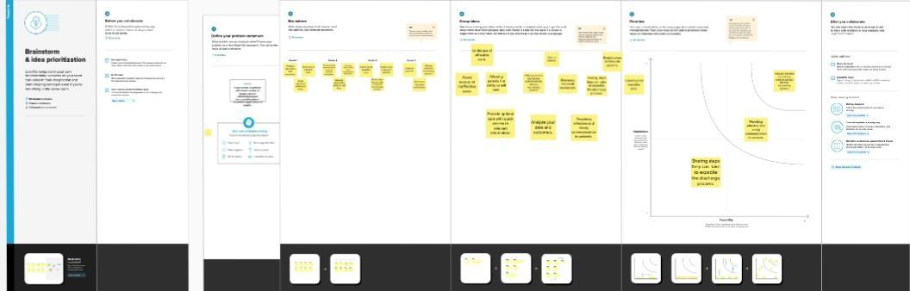

**3.RESULT**

**PROFIT & LOSS BALANCE SHEET**

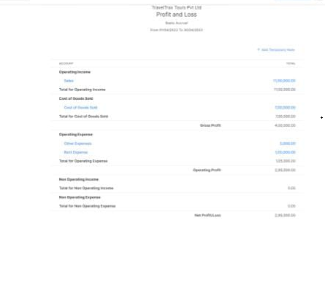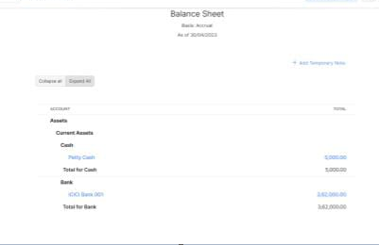

**4.ADVANTAGES & DISADVANTAGES**

**Easily manage prescriptions**

Conveniently request refills to existing prescription or repeat a previous prescription.

**Stay connected to healthcare and lifestyle facilities and services**

Access an extensive directory of healthcare and lifestyle facilities and services, such as locations of polyclinics, healthy food places and sports facilities.

**DISADVANTAGES**

**Lack of Preventive Care:**

Preventive care is undervalued in India, despite the fact that it has been shown to be quite beneficial in alleviating a variety of difficulties for patients in terms of unhappiness and financial losses.

**Policymaking**:

Policymaking is undoubtedly crucial in providing effective and efficient healthcare services. In India, the issue is one of supply rather than demand, and policymaking can help.

**5.APPLICATIONS**

**Zoho Books can also be applied in other Areas , including**

**Track appointments**

With the Caregiver Access module, can grant caregivers access to health and medical records and medical appointments.

**Pay medical fees seamlessly**

Easily pay medical fees via the HealthHub portal without having to visit the clinic or hospital in-person.

**6.CONCLUSION**

To summarize the project done in Zoho Books on financial statements, the Following can be presented:

All three financial statements generated Using Zoho Books will give an overview of Health hub Medical Clinic, which Will help the management make informed Decisions to improve the company’s Profitability and sustainability.

**7.FUTURE SCOPE**

**More Technology**

As genetic diagnosis and treatment translate from cell to bedside, the information and armamentarium available to the clinician will increase perhaps inconceivably over the next 10 yea**rs.**

**Need for a Healthcare Reform**

Between 5 and 10 years from now, the situation will become critical for Americans. The costs for employers will continue to rise, causing many to desire exiting the healthcare business.